TC-CMS-018
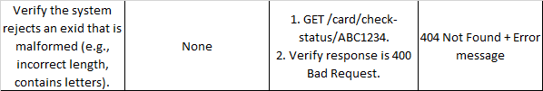
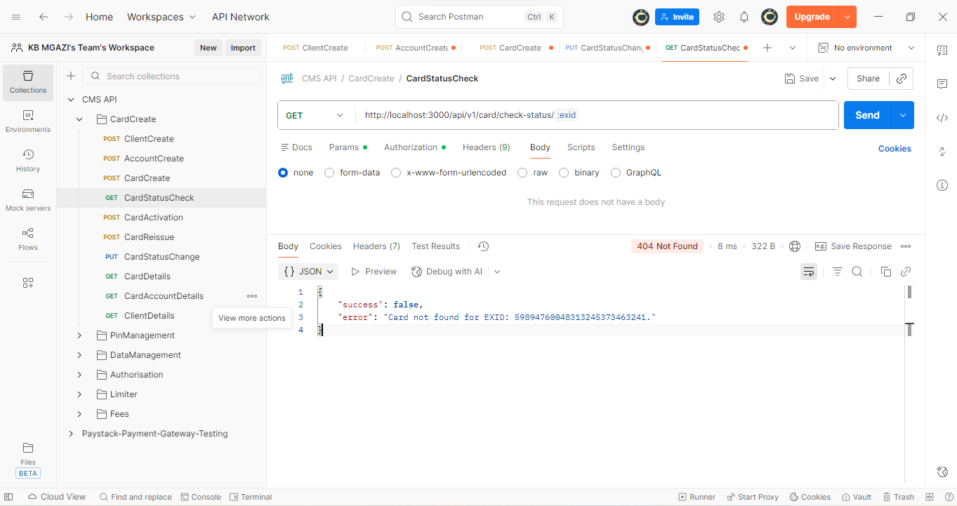
Response:
{
"success": false,
"error": "Card not found for EXID: 59894760048313245373463241."
}

